2023-24 CHBS REGENT UNIVERSITY
HUMAN SUBJECTS REVIEW FREQUENTLY ASKED QUESTIONS

1. What is a “human subject”?

The Code of Federal Regulations at 45 CFR 46.102(f) defines “human subject” as “a living individual about whom an investigator (whether professional or student) conducting research obtains (1) Data through intervention or interaction with the individual, or (2) Identifiable private information.”

2. What is “human subjects review”?

“Human subjects review” is an institutional and governmental required evaluation of certain proposed projects and investigations to ensure their compliance with ethical standards for the protection of human research subjects by treating them humanely, maintaining their dignity, and preserving their rights. Federal, state and university regulations require that the use of human subjects in research be reviewed and approved by Human Subjects Review Board (“HSRC” or “Board”). See http://www.hhs.gov/ohrp/humansubjects/guidance/45cfr46.htm for federal regulations and http://www.regent.edu/academics/academic_affairs/handbook.cfm for the Regent University policy on the Protection of Human Subjects in Research.

3. What is considered “research”?

The Code of Federal Regulations at 45 CFR 46.102(d) defines “research” as “a systematic investigation, including research development, testing and evaluation, designed to develop or contribute to generalizable knowledge.”

4. Does my study require review?

If you are a faculty, staff, or student at Regent University and your research involves the use of human subjects (either directly or through records or other data) and you intend to externally disseminate the results (e.g., via publication, presentation, grant application, etc.) then your research requires human subjects review.

5. What about course assignments that involve surveys or other contact with human subjects?

Assignments which are part of normal, typical coursework that are not intended for dissemination are not required to undergo HSRC review; however, faculty are responsible for informing students of proper procedures regarding the conduct of such research and for monitoring the work done by students. Human subjects data collected in such class assignments may not be used in future publications or presentations. There will be no ex post facto approval of such activities to legitimize turning these studies into approved human research.

6. What about program or institutional improvement surveys or similar efforts?

Surveys or other data collection efforts for the purpose of program or institutional improvement and are not intended for dissemination are not required to undergo HSRC review; however, such efforts must be conducted in an ethical manner that includes appropriate participant protections. Human subjects data collected in such internal improvement efforts may not be used in future publications or presentations. There will be no ex post facto approval of such activities to legitimize turning these studies into approved human research.

6b. What about research with children, prisoners, vulnerable populations, or international research? Due to the nature of this research, it is possible the HSRC at Regent University would require expert consultation, submission to an IRB, or collaboration with external expert researchers.

CHILDREN: Anyone under 18 who is a participant in research has special ethical considerations since they cannot legally give consent to participate in research. Parent or guardian consent is the most common protection, but other protections may be needed when children are the subject of participation in a study. Researchers should become knowledgeable on ethical procedures for children. Many University websites like the University of Virginia IRB website have good information on research with children. https://research.virginia.edu/irb-hsr/vulnerable-subjects-children-minors

PRISONERS: Prisoners are considered a vulnerable population because they have legal and social vulnerability in their role as prisoner. Guidance from OHRP: https://www.hhs.gov/ohrp/regulations-and-policy/guidance/faq/prisoner-research/index.html

VULNERABLE POPULATIONS: Vulnerable populations can include any participant sample with various types of vulnerabilities. This can include people with certain medical or mental health diagnoses, suicidal people, adults with diminished cognitive capacity, participants in dire situations, minority/ ethnically disadvantaged groups, child abuse, domestic violence, institutional vulnerability (people living in institutions), people in deferential roles (when the researcher – participant relationship is deferential such as professor/ student, employer/employee; medical or mental health provider/ patient, etc.), people in economic disadvantage, legal vulnerability, and pregnant women/ fetuses. If the target of your research is any of these populations, you should become aware and take any reasonable pre-cautions to protect vulnerable populations. UVA IRB website has good information on this: https://research.virginia.edu/irb-sbs/vulnerable-participants. If your research of “normal” adult population happens to include people from these vulnerable groups, this is less of a concern. But if your research is targeted for these populations, you should address your plan for protections in your research description.

INTERNATIONAL RESEARCH: For international research there are guidelines that vary by the country, and whether you will be collecting the data or people within the country will be collecting the data. Please consult the OHRP for assistance in ethics in research where participants do not live within the United States. https://www.hhs.gov/ohrp/international/index.html
We also strongly suggest researchers contact the HSRC as early as possible in the planning process for all international research. International research may need translation verification submitted, and will need to receive approval from a credible ethics expert or host country institution authorized to provide ethics review prior to submission to Regent’s HSRC.

7. Does all research go through the same review process?

The depth of the review process is dependent upon the type of research that you are proposing. HSRC reviews are classified as exempt, expedited, or full board review. Each of these categories requires a submission to the Human Subjects Review Committee, although the review time and procedures vary.

8. How do I know in which category (exempt, expedited, full) my application belongs?

The HSRC application has a checklist to help you determine in which category your application belongs, although the HSRC will review your submission and make the final determination of the application type. The criteria used to determine exempt review are available online at https://www.hhs.gov/ohrp/regulations-and-policy/decision-charts/index.html

9. How do I begin the review process?

Complete a Human Subjects Review Form found online and submit it to the Chair of the Human Subjects Review Committee for your department in the SPC. Be sure to include all relevant information (grant proposals, consent forms, questionnaires, test instruments, advertisements, debriefing statements, contact letters, etc.) in accordance with the requirements of your research category. If you are a student working under the guidance of a faculty member (e.g., sponsored research, thesis, or dissertation), you must secure the approval of your faculty advisor before submitting your application to the board.

10. What will happen to my application?

When the Human Subjects Review Committee Chair receives your application, your proposal will be examined to determine whether it warrants exempt, expedited, or full board review. After completing the review process, the HSRC will reply with a letter of approval, request for further information or revisions, or a letter of rejection. The Committee reviews the proposed purpose, procedures, and subject populations to be used and determines if the benefits of the activity outweigh the risks to subjects. Issues considered in this analysis include ensuring that risks to the subjects are reasonable in relation to anticipated benefits, selection of subjects is equitable, informed consent is properly sought and documented, adequate preparation is taken to protect the privacy and confidentiality of subjects, and adequate provisions are made for the ongoing monitoring of the subjects’ welfare.

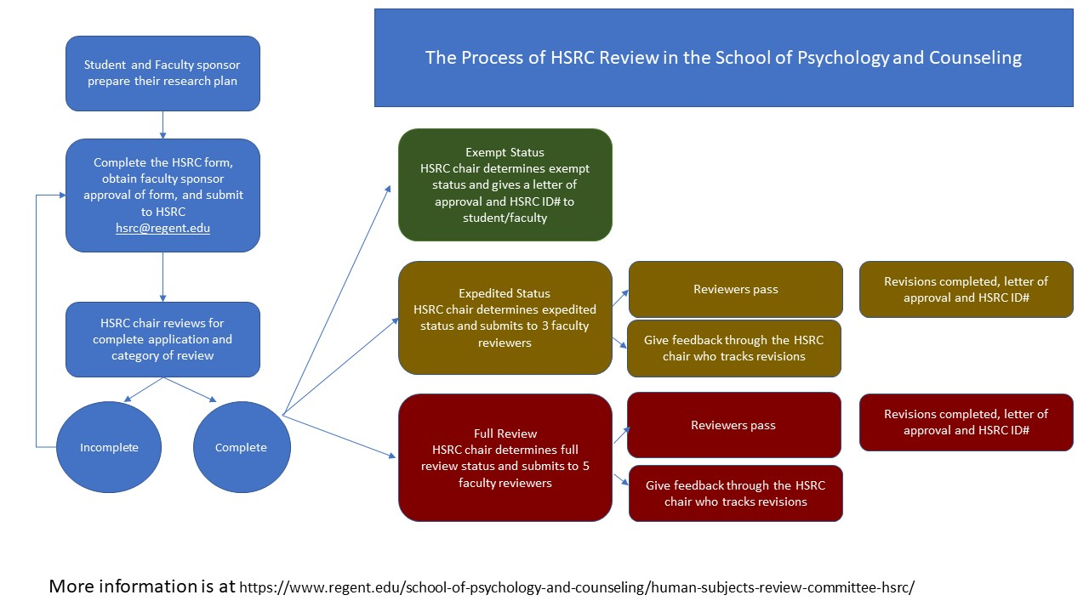

11. Is a research request ever denied?

Yes. If the HSRC determines that the risks of a proposed activity outweigh the benefits or that the proposed research is not in alignment with the guidelines found in 45 CFR 46 for the protection of human subjects in research, it will reject the application. However, in most situations, the HSRC will present the concerns to the researcher and provide an opportunity for modifications rather than simply denying the request.

12. How long does this process take?

The estimated review timeframes are one week for exempt reviews, two weeks for expedited reviews, and one month for full board reviews.

13. When can I begin data collection?

After you receive approval. You will receive a letter from the committee chair responding to your application, and you are required to wait for approval before beginning any research. Collecting any data from any person prior to approval from HSRC is considered a serious ethical breach.

14. How do I change my research after it has been approved?

You must notify the HSRC if you wish to change your research. You can make minor and administrative changes by submitting a written summary describing the proposed changes. Substantial changes in the focus, procedures, or subject population of the research may require submission of a new or revised application.

15. How long is approval valid?

Approval is good for one year. If you will be collecting data after the one-year anniversary of your approval, you will be required to submit a renewal request using the Human Subjects Research Annual Renewal Request Form to secure an additional twelve-month extension. You may repeat this process for as many years as necessary just as long as you don’t substantially alter your original research request.

16. Do I need to submit anything to the HSRC after the research has been completed?

No. If you complete your study in less than 12 months and there are no adverse impacts or changes in protocol that required communication with the HSRC, then your study will automatically expire and be closed at the 12 month time point.

17. Is training and information available?
Yes- Information on training is available on the HSRC website. You need to complete this training prior to submitting your HSRC. You may also find specific information on questions about general research ethics from the IRB websites of large research institutions such as the University of Virginia (https://research.virginia.edu/irb-sbs/irb-sbs-101_ )

18. Whom do I contact if I have more questions?

If you have additional questions, please contact the HSRC chair through hsrc@regent.edu

REGENT UNIVERSITY
HUMAN SUBJECTS REVIEW COMMITTEE APPLICATION

Prior to submission, get approval from the faculty sponsor. Then submit one electronic copy of this form to HSRC https://docs.google.com/forms/d/e/1FAIpQLSeoAGoFVq3DfrE-iP0XuWzaHwBZhIc45c9vgUD6rOezbXCvjg/viewform (faculty mentors should be copied on all communication)

1. PROJECT REVIEW

□ New Project (The HSRC will assign an ID#)
□ Revised Project (Enter original ID):
□ Annual Renewal (complete the annual review form unless changes are extensive)

2. PROJECT TITLE:

3. Personnel
Regent Professor Overseeing the Research:
Phone: Email:
Student Co-Investigator (if any):
Phone: Email:
List of all additional project personnel who will be handling study data or interacting with participants including faculty, staff, outside individuals or agencies:

If you are a student, please provide the following additional information:
This research is for: □ Dissertation □ Thesis □ Independent Study
□ Other ___________________________________________
Academic program: □ Psy.D. □ CES □ MHPS
□ Other ___________________________________________
What is the role of each member of the team? (For educational information: https://www.apa.org/research/responsible/publication/ and https://www.counseling.org/knowledge-center/ethics/code-of-ethics-resources )

Principal Investigator:
Co-Investigator:
Co-Authors or Presenters:
Other:

4. TRAINING

□ All researchers who will handle the data have completed HSRC training (link to online training https://www.regent.edu/school-of-psychology-and-counseling/human-subjects-review-committee-hsrc/#forms) .
Training Date:

5. IS THIS RESEARCH BEING SUBMITTED AS PART OF A FUNDED RESEARCH PROPOSAL? □ Yes □ No

If yes, please identify the funding source:

6. ANTICIPATED LENGTH OF HUMAN SUBJECTS CONTACT:

Beginning Date: Ending Date:

NOTE: all HSRC approvals are for one year. If still collecting data after 1 year a renewal is required.

7. DESCRIPTION OF PARTICIPANTS:

Anticipated Number:
Age Range:
Briefly describe subject population:

8. INDICATE THE REVIEW CATEGORY FOR WHICH YOU ARE APPLYING.

Decision tree to assist with guidance for type of review
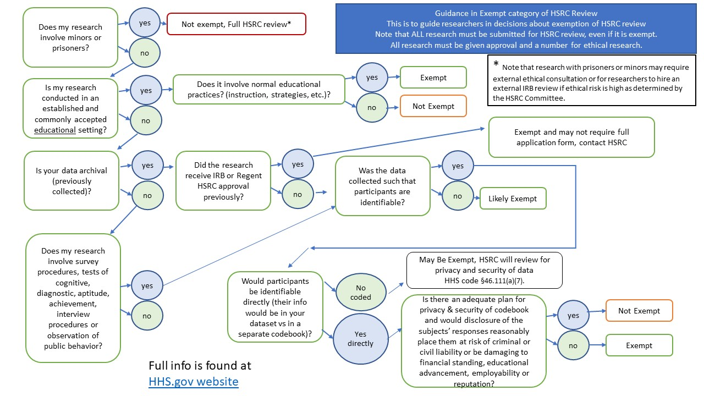

- I am applying for an exempt review, based on one or more of the following categories (check all that apply): Note: Exempt review cannot be claimed for any research involving prisoners, children or vulnerable populations. https://www.hhs.gov/ohrp/regulations-and-policy/decision-charts/index.html

- Research conducted in established or commonly accepted educational settings and involving normal educational practices such as (i) research on regular and special education instructional strategies, or (ii) research on the effectiveness of or the comparison among instructional techniques, curricula, or classroom management methods
- Research involving the use of survey procedures, educational tests (cognitive, diagnostic, aptitude, achievement), interview procedures or observation of public behavior, if information from these sources is recorded in such a manner that participants cannot be identified, directly or through identifiers linked to the subjects; and (ii) any disclosure of the human subjects' responses outside the research could reasonably place the subjects at risk of criminal or civil liability or be damaging to the subjects' financial standing, employability, or reputation
Note: This category cannot be used for research involving children
- Research involving the use of survey procedures, educational tests (cognitive, diagnostic, aptitude, achievement), interview procedures, or observation of public behavior, if (i) the human subjects are elected or appointed public officials or candidates for public office; or (ii) federal statute(s) require(s) without exception that the confidentiality of the personally identifiable information will be maintained throughout the research and thereafter
- Research involving the collection or study of existing data, documents, records, pathological specimens, or diagnostic specimens, if these sources are publicly available or if the information is recorded by the investigator in such a manner that subjects cannot be identified, directly or through identifiers linked to the subjects. Please answer these sub-questions here for this item if you are using previously collected information.
  - Was this research previously approved by this HSRC?
    - IF yes, what date, please include approval letter/document.
  - Was this research previously approved by another ethics committee?
    - IF yes, please include approval letter/document from that committee.
  - Was this research previously collected by this same faculty supervising researcher?
    - If no, where does the information/data reside now?
  - Who will physically or electronically collect the existing information from where it is stored now?
  - Did the original participants offer consent for research participation?
    - If yes, please include their consent document as addendum.
  - Will there be any way to identify (directly or through identifiers) the original subjects by the researcher/s?
  - How will the information be stored by the researchers?
  - How will security of data be ensured?
  - What research question and measures are you utilizing from this existing information?

- Research and demonstration projects which are conducted by or subject to the approval of federal department or agency heads, and which are designed to study, evaluate, or otherwise examine (i) Public benefit or service programs; (ii) procedures for obtaining benefits or services under those programs; (iii) possible changes in or alternatives to those programs or procedures; or (iv) possible changes in methods or levels of payment for benefits or services under those programs

- I am applying for an expedited review, based on meeting all of the following conditions (check all that apply): Note: Expedited review cannot be claimed for research involving prisoners, children or vulnerable populations.

- Research poses no more than minimal risk to subjects (defined as "the probability and magnitude of harm or discomfort anticipated in the research are not greater in and of themselves than those ordinarily encountered in daily life or during the performance of routine physical or psychological examinations or tests.")
- Research limited to one or more of the following data collection procedures:
  - Collection of data through noninvasive procedures routinely employed in clinical practice
  - Research involving materials (data, documents, records, or specimens) that have been collected, or will be collected solely for nonresearch purposes
  - Collection of data from voice, video, digital, or image recordings made for research purposes
  - Research on individual or group characteristics or behavior (including, but not limited to, research on perception, cognition, motivation, identity, language, communication, cultural beliefs or practices, and social behavior) or research employing survey, interview, oral history, focus group, program evaluation, human factors evaluation, or quality assurance methodologies
Note: Some research in this category may be classified as exempt; this listing refers only to research that is not exempt.
  - Continuing review of research previously approved by the convened HSRC as follows: (a) where (i) the research is permanently closed to the enrollment of new subjects; (ii) all subjects have completed all research-related interventions; and (iii) the research remains active only for long-term follow-up of subjects; or (b) where no subjects have been enrolled and no additional risks have been identified; or (c) where the remaining research activities are limited to data analysis.

- I am applying for full-committee review (all research that is not exempt or expedited. For example research involving children, prisoners, vulnerable populations, international research where participants may have few protections or higher risk, information involving mandatory reporting to authorities, deception or any greater than minimal risk)

HSRC Project Description Checklist
Please answer to each of these questions yes or no, and for applicable questions, describe in space provided. | Type in Yes or No in the box below
- Is your data completely anonymous, where there are no possible identifications of the participants? (IP addresses common to online data collection are not anonymous)
- Will you be using existing data or records? If yes, describe below and in project description (#9 below)
B explanation
- Will you be using surveys, questionnaires, interviews or focus groups with subjects? If yes, describe below and include copies of all in application._
C explanation
- Will you be recording video, audio, film? If yes, will participants be identifiable? If yes, describe below.
D explanation
- Do you plan to use any of the following populations? Regent students, Regent employees, Non-English speaking, people living outside of the United States, people with certain medical or mental health diagnoses, suicidal people, adults with diminished cognitive capacity, participants in dire situations, minority/ ethnically disadvantaged groups, child abuse, domestic violence, institutional vulnerability (people living in institutions), people in deferential roles (when the researcher – participant relationship is deferential such as professor/ student, employer/employee; medical or mental health provider/ patient, etc.), people in economic disadvantage, legal vulnerability, and pregnant women/ fetuses? If yes, describe below.
E explanation
- Do you plan to use minors (under 18)? If yes, describe below and give age ranges.
F explanation
- Are sites outside of Regent engaged in the research? If yes, describe below and give consent letter or their HSRC information.
G explanation
- Are you collecting sensitive information such as sexual behavior, HIV status, recreational drug use, illegal behaviors, child/elder/physical abuse, immigrations status, etc.? If yes, describe below.
H explanation
- Are you using machines, software, internet devices? If yes, describe below.
I explanation
- Are you collecting any biological specimens? If yes, describe below.
J explanation
- Will any of the following identifying information be collected: names, telephone numbers, social security number, fax numbers, email addresses, medical records numbers, certificate/license numbers, Web universal resource locators (URLs), Internet protocol (IP) address numbers, fingerprint, voice recording, face photographic image, or any other unique identifying number, code or characteristic other than “dummy” identifiers? If yes, describe below.
K explanation
- Will there be data sharing with any entity outside your research team? If so, describe below.
L explanation
- Does any member of the research team or their family members have a personal financial interest in the project (for commercialization of product, process or technology, or stand to gain personal financial income from the project)? If yes, describe below.
M explanation
- As applicable, do you plan to provide a debriefing to your participants? If written, include in application as addendum.
N explanation
- Will there be any inducement to participate, either monetary or nonmonetary? If there is inducement please describe how the amount is not coercive below.
O explanation
- Will there be any costs that subjects will bear (travel expenses, parking fees, professional fees, etc. If no costs other than their time to participate, please indicate)? If yes, describe below.
P explanation
- Will subjects be studied on Regent University campus? If yes, please describe where the study will be done below.
Q explanation
- Will subjects be obtained by internet only? If yes, please describe what internet forums or venues will be used to obtain participants below.
R explanation
- Are you using the Regent University consent form template? Whether using the template or requesting an alternate form, you must include a copy in your submission.

9. PROJECT DESCRIPTION
Briefly describe the methodology and objectives of your research (including hypotheses and/or research questions), the data collection procedures, and any features of the research design that involve procedures or special conditions for participants, including the frequency, duration, and location of their participation. The description should be no longer than 2 pages single-spaced. Simple studies may only be a paragraph description. Attach addendums for materials and detailed descriptions of the research if more space is needed. Please note that complete chapters of thesis/dissertation proposals will not be accepted.

General Response:

10. PARTICIPANT RECRUITMENT
Describe the sources of potential participants, how they will be selected and recruited, and how and where you will contact them. Describe all relevant characteristics of the participants with regard to age, ethnic background, sex, institutional status (e.g., patients or prisoners), and their general state of mental and physical health.

Response:

11. INFORMED CONSENT
Describe how you will inform participants of the nature of the study.

Attach a copy of your cover letter, script, informed consent form and other information provided to potential participants.

Response:

12. DISSEMINATION & STORAGE OF RESULTS
- How and where do you plan on disseminating the results of your study?
- For electronic data stored on a computer, how will it be stored and secured (password, encryption, other comparable safeguard)?
- For hardcopy data, how will it be stored (locked office or suite, locked cabinet, data coded by team with master list secured separately, other)?
- What are your plans for disposing of data once the study is ended (give method and time, note that 3 years from completion is standard for data, longer for clinical or healthcare data in keeping with healthcare standards)?

Response:

13. WRITTEN CONSENT

□ I am requesting permission to waive written consent, based on one or more of the following categories (check all that apply):

□ The only record linking the subject and the research would be the consent document, and the principal risk would be potential harm resulting from a breach of confidentiality.
□ The research presents no more than minimal risk of harm to subjects and involves no procedures for which written consent is normally required outside of the research context.

□ I will be using a written consent form. Attach a copy of the written consent form with this application.

14. CONFIDENTIALITY OF DATA
What procedures will be used to safeguard identifiable records of individuals and protect the confidentiality of participants?

** EXEMPT and EXPEDITED APPLICATIONS SKIP TO QUESTION 17: ATTACHMENTS **

15. RISKS AND BENEFITS
Describe in detail the immediate or long-range risks, if any, to participants that may arise from the procedures used in this study. Indicate any precautions that will be taken to minimize these risks. Also describe the anticipated benefits to participants and to society from the knowledge that may be reasonably expected to result from this study.

Response:

16. DEBRIEFING STATEMENT
The two major goals of debriefing are dehoaxing and desensitizing. Participants should be debriefed about any deception that was used in the study. Participants also should be debriefed with information about how to access medical or mental healthcare if the study targeted participants with medical or mental health diagnoses. Please describe your debriefing plans and include any statements that you will be providing to the participants.

Response:

17. ATTACHMENTS:
Attach copies of all relevant project materials and documents, including (check all that apply):
- A copy of your CITI HSRC training certificate (required for principal investigator & faculty sponsor; note expiration dates and renew if needed)
- Surveys, questionnaires, and/or interview instruments
- Informed consent forms or statements
- Letters or emails of approval from cooperative agencies, schools, or education boards
- Debriefing statements or explanation sheet

18. AFFIRMATION OF COMPLIANCE:

By submitting this application, I attest that I am aware of the applicable principles, policies, regulations and laws governing the protection of human subjects in research, and that I will be guided by them in the conduct of this research. I agree to follow the university policy as outlined in the Faculty & Academic Policy Handbook (available at https://www.regent.edu/academics/academic_affairs/faculty_handbook.cfm) to ensure that the rights and welfare of human participants in my project are properly protected. I understand that the study will not commence until I have received approval of these procedures from the Human Subjects Review Committee. I further understand that if data collection continues for more than one year from the approval date, a renewal application must be submitted.

I understand that failure to comply with Federal Regulations (45 CFR 46, available at https://www.hhs.gov/ohrp/regulations-and-policy/regulations/45-cfr-46/index.html) and all relevant laws and professional ethics can result in confiscation and possible destruction of data, suspension of all current and future research involving human subjects, or other institutional sanctions, until compliance is assured.

Principal Investigator Sign here:

For students, I attest that this submission has first been reviewed and I have received any feedback and made revisions satisfactory to my faculty advisor prior to submission .

- Yes, my faculty mentor approves this submission (copy your mentor on all HSRC emails)

Attach or paste informed consent, instruments, memos, debriefing statements etc. here.

Submit to https://docs.google.com/forms/d/e/1FAIpQLSeoAGoFVq3DfrE-iP0XuWzaHwBZhIc45c9vgUD6rOezbXCvjg/viewform

Note you can only submit documents (Word or similar format) and PDF files to this system. No image files or other types of files.

