FAC 100

Technology for
Student Engagement

Attentive Instructors: What Our Students Are Saying

“Faculty interaction in an online course is imperative. I often feel like I am learning everything on
my own.”

Advise Alert

If you have a student whom you consider to be at-risk--whether it be for financial, academic, or well-being issues--the University has a system that allows advisors and staff to act quickly and in an informed manner to reach out to the student and offer help.

• Learn more about Advise Alert

IMPORTANT NOTE: Filing an Advise Alert is REQUIRED if a student is in jeopardy of failing a course.

Part of your journey towards increasing student engagement and striving towards teaching excellence will be utilizing the feedback from your students' evaluations. As you evaluate this feedback. Please, consider the following steps after you receive your evaluations.

• Evaluate what reoccurring themes or comments are written by students.
• Develop a personal improvement plan for increasing student engagement in your courses.
• Communicate with your dean about steps for improving your courses and what changes could be made to the approaches.
• Consult with Regent University's Center for Teaching and Learning to learn about engagement strategies, course design methods, or instructional technologies to integrate into your teaching practices.

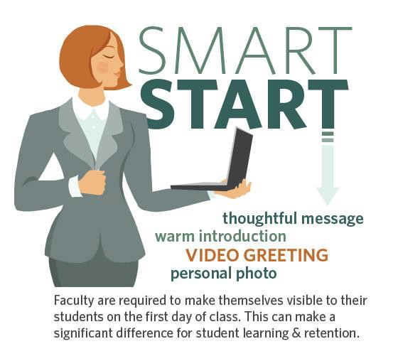Establishing Instructor Presence

Simply put, instructor presence is the means by which we convey to learners that there is someone there who is participating, someone who is directing the educational experience. The ways in which instructors establish this presence in an online environment can have important implications for the students' overall learning experience (Richardson, Besser, Koehler, Lim, & Strait, 2016).

Connecting Through Technology
In the students’ own words

“Having responses along with graded assignments is fine, but I have felt most connected through email…about my specific progress in class and in the program.”

"Having online office hours helps build the student-instructor connection."

"I really like the live class sessions…It makes me feel like I am really in class versus being online.”

Establishing a Presence Through E-mmediacy Strategies: Online Connectedness Via
Social Cues

Cues that reveal the instructor:

• Expressing humor
• Exhibiting emotions
• Providing self-disclosure
• Interjecting allusions of physical presence

Cues that recognize the learner:

• Using greetings
• Addressing people by name
• Complimenting others' ideas
• Offering support or agreement for an idea

Strategies to establish presence:

• Using computer-mediated communication (chat, videos, web conferencing)
• Providing immediate feedback in an online setting
• Establishing a pattern of communication
• Engaging in eye contact, gestures, and personal recognition to close the distance

Communication and Instructor Presence

When emailing students, there are two options:

Bb Email

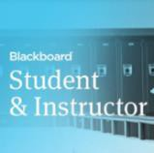Bb is equipped with a feature that allows you to email users who are enrolled in the course. You may choose to send an email to one or more individuals, entire groups, only instructors, or the entire class. The email feature is accessible via the Tools link in the left navigation or from the instructor Control Panel under Course Tools. A copy of every message sent via Bb email is sent
to the user's Regent account so that you will have a copy of all correspondence sent out from Bb. Although you can send messages from Bb, you cannot check your email from within Bb. Messages sent from students in Bb will go to your Regent account. For more information, click the image below to watch the Sending Email tutorial, which will open in a new window.

Regent Email

The easiest way to access your Regent email is from the Regent Portal. To help manage incoming student email, you may find it useful to create folders for each semester and/or class. Doing so provides a reliable and efficient system to organize communications related to your course.

It's important to establish appropriate response times for calls or emails from students and to communicate these times clearly. Although a 24 hour response time is generally acceptable, your dean/department chair may have other requirements, so be sure to check with whichever school you are teaching for. Information on response times, in addition to your preferred method of contact (email, phone, text) should be included in the course syllabus and in Bb on your Instructor Info page. You may also wish to include this information in your welcome/opening announcement at the start of the course.

Instructors communicate with learners in a variety of ways. Two of the most
effective are through sharing and feedback. Below are some suggestions for establishing or improving your
communication strategies.

Sharing as a Communication Strategy

• Use an introductions forum to allow learners to post their background, picture, personal information, general thoughts on the course, or any other information they'd like to share with the class
• Use the Instructor Info page or introductions forum to share enough information about yourself so that learners recognize you as an expert, while also portraying yourself as someone who is relatable,
friendly, and open

Feedback as a Communication Strategy
• Provide more than a grade in order to let learners know where they have room for improvement
*Tip: Use the rubric tool is Blackboard to provide standardized feedback and pair this feedback with personalized notes and examples.
• Provide feedback quickly and include positive or encouraging comments along with any negative ones
*Tip: Feedback should be provided within 7 days.
• Avoid a scolding tone or negative comments within public spaces

Overall Communication Strategy

• Be approachable
• Show concern for learner success
• Demonstrate expertise
• Model expected behaviors in discussions
• Create a balance between personal and professional information in order to create an instructional presence that is welcoming, friendly, and helpful

Learners understand the importance of feeling connected to their instructor and recognize instructor presence in their courses. Below are some common means for instructors to connect with learners, along with reflections from these learners about the effectiveness of these approaches.

Connecting through technology
“Having responses along with graded assignments is fine, but I have felt most connected through email…about
my specific progress in class and in the program.”

“The fact that my instructors email on a weekly basis…makes it feel as if they are trying to stay connected to the students.”

"The use of Skype helped connect me with the professors to develop these personal
relationships.”

"Having online office hours helps build the student-instructor connection."

“I have had a professor email me…to make sure that I was doing ok and would be able to complete the course.”

"I really like the live class sessions…It makes me feel like I am really in class versus being
online.”

Connecting through instructor feedback

“One particular professor…assisted when I was not clear on certain assignments that required advanced skills and knowledge for presenting the work.”

“The instructor that I do feel connected with gives us feedback every week on our assignments.” “Quality feedback...includes comments, not just a grade.”
“Lack of explanation on the reduction of points makes it difficult to know what was done incorrectly and how to improve.”

Overall connections with instructor

“Having the professor be interactive in our online courses has really helped in my course work (since we don’t
have the face-to-face component with online courses).”

"I can honestly say that all instructors that I have had made me feel connected to them with clarity of
expectations.”

“I’ve had basically zero interaction with my profs because they are not involved in their courses other than to assign readings and give homework/projects.”

Enhancing Instructor Presence Through Regent Live

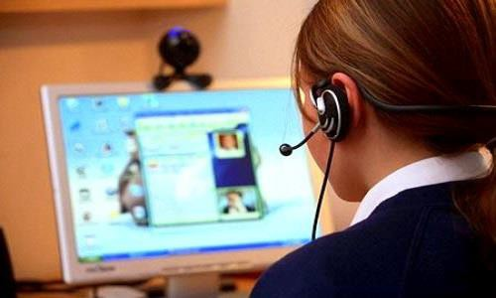Regent Live is a university-wide initiative to ensure that all online students are given the opportunity for meaningful live engagement with their course faculty. When teaching an online course, a Regent Live should be conducted during the first two weeks to establish an early instructor presence.

Procedure

During the first week of class, faculty will contact every student and invite them to a live engagement opportunity with the professor.

• This invitation must be pushed to the student and not merely posted in a syllabus or Blackboard course site.
• This invitation can be communicated through an email message, text message, telephone call, face-to-face announcement, or other similar means.

Faculty should provide the live engagement opportunity by the end of the second week of class. Live engagement opportunities may include the following:

• A synchronous online session (e.g., Zoom, Google Hangouts, etc.).
• A face-to-face class session.
• A one-on-one conversation (e.g., office hour appointment, telephone call, Zoom session, etc.).

Regent Live Protocols

The Regent Live survey will be emailed to you through your school representative. Please complete this survey quickly in a timely manner.

Faculty Focus: Real Instructor Examples of Regent Live Sessions

Idea 1: Use Regent Live to mirror the energy of the face-to-face classroom. Ask reflective questions to students and have them engage in live debates either in the main room or in separate breakout rooms.

Idea 2: Create opportunities for collaboration and authentic learning through Regent Live. Have your students enter into a problem-solving scenario and require them to collaborate to identify solutions.

Idea 3: Take advantage of the direct content with your students by clarifying key course elements, assignment requirements, and course outcomes. Engage with your students in Q/A to make sure they understand course expectations.

Idea 4: Establish a consistent instructor presence by holding regular office hours. Encourage your students to come with questions or touch base with you as they progress through the course.

