FAC 100
Regent Teaching
Essentials

General Course Protocol

Each course should include a syllabus approved by your department chair, dean, or designee. The date by which syllabi are due varies depending on school and program, so be sure to verify with the school you are teaching for exactly when syllabi are due and to whom they should be submitted. Syllabi are developed based on the University's syllabus template, but some schools may have additional elements that they require. Again, check with the school you're working with to determine specific requirements.

Instructors must record final course grades in the Bb Grade Center, as well as submitting them via Genisys. Grades are due at the end of each session/semester, but the dates vary depending on whether the course is held during the first eight weeks, second eight weeks, or full semester. The academic
calendar provides specific information pertaining to final grade due dates.

At the conclusion of each course, students will be asked to complete a Student Evaluation of
Teaching survey (SET). This survey is administered online through an automated system. Students will be notified via email that the course survey is available. Surveys are available one week prior to the course end date and remain available for one week after the course end date. Faculty will receive an email when survey results are available for their review.

SET survey questions relate to several areas:

 Clarity of Learning Outcomes
 General Instructor Support of Student Learning
 Instructor Effectiveness in Moderating Course Interactions
 Learner Satisfaction
 Learner Perceptions of Course Strengths and Weaknesses

What is FERPA?

Please, take some time to familiarize yourself with general information about FERPA that you may need to know for instructing students.

Course Management Recommendations

Learner success in an online course is influenced by many factors. Some of these factors relate to learner characteristics or ability, while others relate to how instructors manage their course and interact with learners. Below are 10 recommendations that are considered extremely important for learner success in an online environment:

1. Provide clear instructions regarding schedules and due dates
2. Provide a detailed class calendar that includes due dates for postings, papers, and projects
3. Respond to postings and emails within 48-72 hours
4. Provide clear instructions regarding acceptable length/quality of required online communications
5. Demonstrate respect for the learning process by exhibiting excellence in creating/presenting content

6. Provide supportive/corrective guidance privately rather than in a public venue
7. Express belief that students will be successful in the online setting and verbalize enthusiasm for learning
8. Refer to specifics when providing feedback on student work
9. Provide opportunities for synchronous meetings
10. Recount challenges experienced in the online setting and share remedies that have worked for self and others

How to Submit Your Grades in Genisys

1. Access Genisys by logging into the Regent Portal at my.regent.edu. Enter your RegentID when requested.
2. Select Faculty & Advisors.
3. Select Semester Selection.
4. Select the correct semester from the drop down menu; click Submit.
5. Select CRN Selection (Course Selection).
6. Select the correct course from the CRN drop down menu; click Submit.
7. Select Enter Final Grades.
8. Use the drop down grade box beside each student’s name to enter the grade.
9. Be sure to click the Submit button at the bottom of each page.
10. After you have submitted grades for one class, scroll down to the bottom and click the link for “CRN Selection” to pick the next course

For additional forms or information related to instructional protocols, please, see the course resources area in the left navigation panel.

Managing Announcements

There are several ways to manage course announcements. Although listed as three separate options (see image below), you may combine them as needed to achieve the announcement settings you desire.

Option 1: All announcements are visible all of the time, with the most recent on top.

While creating the announcement, select Not Date Restricted and make no changes to the display dates. All announcements will show in the order created, with the most recent on top, for the duration of the course.

Option 2: Announcements are visible for a specified period of time.

While creating the announcement, select Date Restricted and select the Display After and Display
Until check boxes and type the dates.

Option 3: Announcements are emailed to students in the course

While creating the announcement, select the Email Announcement check box. All course users (students, instructors, and teaching assistants) will receive an email containing the announcement, which ensures they receive the information even if they do not log in to the course.

Online vs. Face-to-Face Learning

Please, click on the image to the below to activate a tutorial on online vs face-to-face learning.
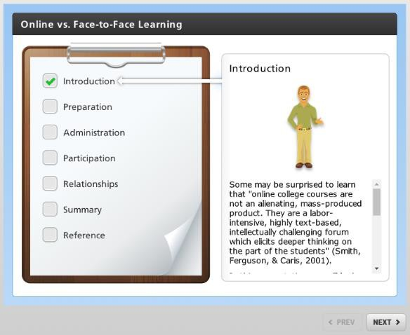

Moderating Effective Online Discussions and Groups

What is the purpose of online discussions?

To…

• Promote a congenial social atmosphere
• Facilitate the lively exchange of views
• Focus attention and effort on important concepts
• Promote critical thinking ad inquiry skills

Benefits of Online Discussions

Online discussions can:

1. Facilitate relationship building, idea sharing, and problem solving
2. Generate increased interaction, collaboration, and trust among students
3. Create a sense of personal presence in the class
4. Reduce feelings of isolation
5. Allow students to actively participate in the construction, testing and application of knowledge rather than being passively learners

Please, click on the image below to activate a study spotlight related to online discussions.

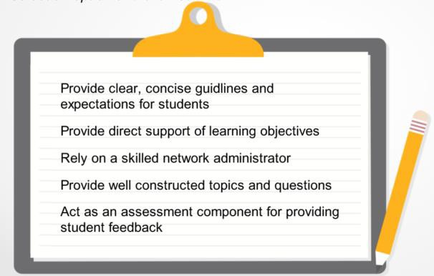

Characteristics of Effective Online Discussions

1. Provide direct support of learning objectives
2. Provide clear, concise guidelines and expectations for students
3. Provide well-constructed topics and questions
4. Rely on a skilled and involved facilitator
5. Act as an assessment component for providing student feedback

Planning & Moderating Discussions

Establish criteria

Explain to students what is expected of them in terms of quantity, quality, and deadlines (use discussion rubric).

Set clear deadlines

Make sure students know how long a discussion will last and when you expect them to post (i.e., first post by Wed at midnight, two response posts by Sat at midnight).

Moderate and lead by example

Be present in the discussion and guide it by participating in the same way you expect your students to participate (model desired behavior).

Summarize the conversation periodically

Discuss how various contributions have been relevant and how students can use this information in their current assignment or task.

Don’t dominate the discussion

Don’t feel the need to respond to every post. Over participation by the instructor can make students feel that their words/thoughts don’t matter as much as those of the instructor.

Participation in online discussion forums is crucial for maximizing student learning experiences in online environments. Online discussions provide an opportunity for learners to activate prior knowledge, posit questions or clarify misconceptions, and interact collaboratively with their
instructor and peers. The assessment component of online discussions allows faculty to enhance instructor presence and guide students through the learning process. There are several approaches to assessing online discussions and providing feedback:

Daily/Every 2nd or 3rd Day Reviews - Reviews and responds to learner posts on a daily/every 2nd or 3rd day basis. The primary purpose of this interaction is to give learners a sense of how they are performing and where adjustments might be warranted.

Interim Reviews – Periodic reviews (weekly, bi-weekly, end of unit, etc.) that serve much the same purpose as those described above, but generally carry a graded component. Interim grades can be added/averaged to determine the final discussion grade.

Targeted Reviews - Posts selected from the beginning, middle, and end of course are used to gauge learner progress over the entirety of the course and assign a final discussion grade.

Learner Generated Reviews - Ask the class to develop (or sign an existing) participation “contract” at the beginning of the course and also submit a reflection at the end of the course. This approach serves as one means of bolstering the learning community as the course begins. Faculty facilitate the process, but learners work together to develop the criteria. As this process is time-consuming, it's generally better to employ with smaller classes or those that deal with high-level, complex content (doctoral courses).

Discussion Rubrics

Best practice highlights the importance of providing clear and concise grading parameters for online discussions. One well-established means to do this is with a discussion rubric. Rubrics help faculty focus the evaluation process and provide a structure that is more likely to lead to student learning. Rubrics come in all shapes and sizes, with the most effective ones addressing both quantity and quality of discussion interactions.

Quantity - Did the learner provide the requisite number of discussion posts within the specified time frame?
Quality - Did the learner provide substantive posts that met the guidelines/descriptors provided on the rubric?

Remember that narrative feedback is also important, so provide learners with comments whenever appropriate. It's not necessary to provide lengthy feedback, such as you might do on a formal written paper. Just offer specific guidance on what they are doing well and where they might need to improve in regard to their online discussions. Providing this type of feedback early in the course--at the conclusion of the first discussion period--will allow learners to reflect on your feedback and incorporate it into subsequent discussion activities.

Your department or school may have a standard discussion rubric that you are required to use. If not, consider the following questions related to learner postings as you develop your own discussion rubric:

1. Is the information accurate?
2. Is the post relevant to the topic under discussion?
3. Does the post answer the questions posed in the discussion prompt(s)?
4. Does the post add something new to the dialogue, challenge an existing perception, or help learners apply concepts in new ways?

Teaching with Technology

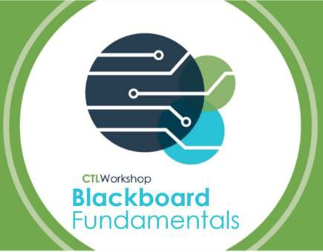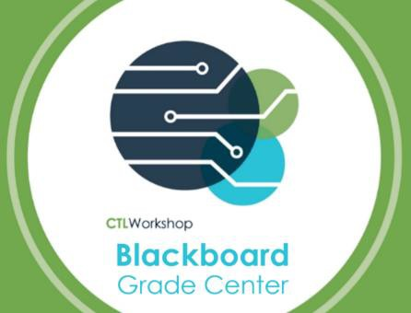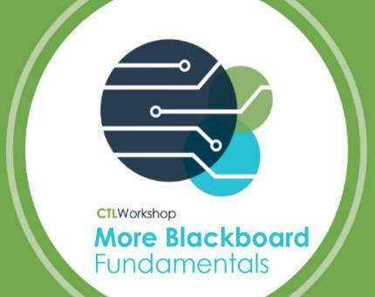To prepare you for your upcoming FAC 100 assignments and also equipment you with the technical skills you will need to teach at Regent, please individually click on each images below, review the information, and complete any required practice.

Zoom

